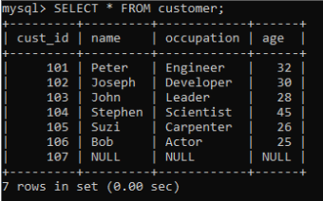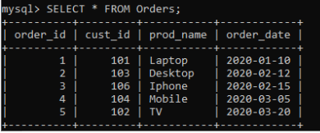

1. Display the order ids of peter and stephen
2. The customer details who have not placed an order.
3. Find the name of the customers who has purchased laptop.
4. Find the details of customers who purchased iphone.
5. Find the details of the customers whose details is not in the orders table.
6. Display the order details of Bob
7. Find the second youngest person in the table.